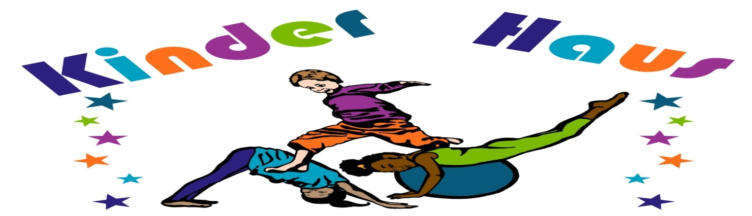
Package A  Kinder Haus  PARTY  $199.00 up to 10 children  each additional child $ 10.00  - Craft activities  - 45 minute Kinder Haus Play Activity  - Personal host and/or hostess for party  - Balloons and decorations  - Paper goods( napkins, cups, plates, utensils, tablecloth)  - Special Gift for the birthday child! Maximum of 22 children | Package B  SUPER  Kinder Haus THEME  PARTY  $245.00 up to 10 children  each additional child $10.00  Includes all the fun of the  Kinder Haus party  PLUS:  - SPECIAL PARTY THEME  - Theme Party supplies  - Choice of pizza or sandwiches for each child  - Choice of juice or water  - 10% DISCOUNT for each guest that signs-up for one (6 week) session of any Kinder Haus Class Discount is good up to a year of party date. Maximum of 22 children

Tax & Gratuities
Not Included
* All participants should wear comfortable attire and proper footwear
*Parental supervision required
Prices May Be Subject To Change

Examples Of Our Themes Include:
Barbie, Disney Princess, Hello Kitty, Strawberry Shortcake, Dora, Cars, Spiderman, Superman, Sponge Bob, Go Diego Go, Wow! Wow! Wubzy , Backyardigans, Little Einsteins, Handy Mandy, Winnie the Pooh, Elmo, Pirates, Fairy, Princess, etc.
PARTY ADD-ONS:
- Goody Bags $ 4.99 & up per child
- Birthday Cakes $ 20.00 - $25.00 (Feeds up to 48 people)
- Large Cheese Pizza $ 14.00 per pie
- Large Pizza (8 slices per pie) $ 15.00 w/ toppings $3.00 .ea
- Sandwich Platter $ 30.00 (Feeds 15-20 adults)
- Juice or water $ 1.50 per child
- Bottled water (per bottle) $ 1.00 per bottle
- Bottled Water (24 bottles) $ 10.00 for 24 bottles
- Juice $ 2.00 per bottle
- Juice (24 bottles) $ 20.00 for 24 bottles
- Chips, Pretzels or Popcorn $ 4.00 per bowl
(per bowl)

Party Policies

Reserving a Party:
- A $75 deposit is required to hold a date for a party. The balance is due day of party.

Waiver and Friendly Reminders:
- All guests must bring a signed waiver to participate in the party.
- All guests and Birthday Child must wear appropriate footwear to participate.
- No alcoholic beverages or smoking on The Pilates Haus premises
- Street parking
- Stroller Parking on Lower level

Arrivals and Departures:
- Please arrive no more than 15 minutes prior to start of party. A $25 fee will be charged for every 15 minutes beyond that grace period.
- A 15 minute grace period is provided after the party end time to allow for Birthday families to collect party items. A $25 fee will be charged for every 15 minutes beyond that grace period.

Changes and Cancellations:
- Party date changes must be made 7 days in advance.
- Cancellations 2 weeks prior to party date will receive deposit refunds.
- Cancellations within 7 days of party date will be charged 50% of party total.
- Cancellations within 48 hours of the party will be charged all party fees.

The Pilates Haus featuring Kinder Haus
155 2nd Street
Jersey City, NJ 07302
(201) 963-0436

Birthday Party Waiver & Release

______________________________________________________________________
Child’s Name Date of Party

______________________________________________________________________
Name of Birthday Child
ASSUMPTION OF RISK AND WAIVER OF LIABILITY
As legal guardian of _____________________________________, hereafter child(ren), I recognize what potentially severe injuries, including permanent paralysis or death can occur in sports or activities involving height or motion, including but not limited to gymnastics, tumbling, dance, birthday parties, special events & activities and any and all other programs offered at The Pilates Haus LLC and Kinder Haus. Being fully aware of these dangers, I voluntarily consent to the aforementioned person(s) participating in any and all of The Pilates Haus, LLC and Kinder Haus programs and activities and I ACCEPT ALL RISKS associated with that participation. In consideration for allowing my child(ren) to use these facilities, I, on my behalf of my child(ren) and our respective heirs, administrators, executors and successors, hereby COVENANT NOT TO SUE and FOREVER RELEASE The Pilates Haus, LLC and Kinder Haus its officers, directors, shareholders, employees or agents from all liability for any and all damages or injuries suffered by my child(ren) while under the instruction, supervision, or control of The Pilates Haus, LLC and Kinder Haus including, without limitation, those damages or injuries resulting from acts of negligence on the part of its officers, directors, shareholders, employees, or agents. By your attendance, you are granting your permission for you and your child to be filmed, videotaped, audio taped, or photographed by a means and are granting full use of your likeness, voice, and words without compensation.

_______________________________________________________________________________________________________________
Parent’s Printed Name

Parent’s Signature Date

